## Merchant

Demo date: Sep 13, 2024

Scoping start date: Sep 13, 2024

MSA Signature Date: Sep 13, 2024  
Onboarding Kick Off Date: Sep 16, 2024

[If Exists] Opt Out Date:  
Go Live Date: Sep 27, 2024

GTM POC: Daniel  
Implementation POC: Royce

ERP: QBO

Tax Integration: No Tax

### 

### Key people at Merchant

### Fractional CFO: Nathan Kiss - nathan@thesbx.co

### VP Customer Success: Alex Burlingame - alex.burlingame@genlogs.io:

### Fractional Analyst: Zoe Costley - zoe@thesbx.co

### Company summary

GenLogs is a freight intelligence company that offers truck carrier mapping services via AI-driven roadside sensors.

Goals (North star)

Full invoicing and revenue automation  
  
AE Notes

Moved super quickly - very friendly team. Nothing to note as they have been doing trials and finished PoC and will now be starting their billing on Oct 1.

### Billing model

* SaaS

### Billing model

* SaaS billed monthly. May test new billing models as they grow.

### Contract Processing Steps

**Notes about Genlog contracts that’s important for processing**

* Their agreement and contract usually start with a one month pilot period (they call this Letter of Intent (LOI)
  + Document Name: **Non Binding Software Access Agreement**
  + Set it up as a one month trial period contract
* Then if the customers decides to continue to with using the software, they will then sign a subsequent contract annually
  + Document Name: **PLATFORM AGREEMENT ORDER FORM**
  + Set it up as 12 months durations

Here’s an example of how it will show in the Items. Noticed the following:

* One time vs. Recurring
* Integration item updates
* Trial period price vs. recurring price for ongoing with discount

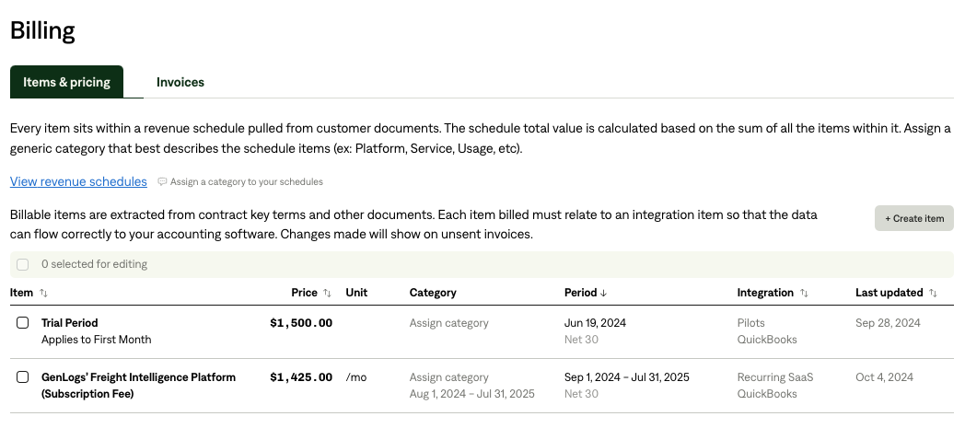

**Send Slackbot for the first invoice post-processing**

1. **Steps to process**
   1. Pull out the customer name in the contracts
   2. Pull out the pricing amount with the discounted price (net)
   3. Use the Effective Date as the date for the Revenue schedule
   4. For the Billing term,
      1. Billing date - the first date of the following month from the contract effective date
      2. Billing frequency is monthly
      3. Duration is 12 months or 1 month depending if it’s the
2. **Anything to ignore in contracts?**
3. **Default Service Term**
   1. Non Binding Software Access Agreement = 1 month
   2. PLATFORM AGREEMENT ORDER FORM = 12 months
4. **Default Net Payment Terms** 
   1. If None, Ops Default is 0
5. **Integration item**
   1. Non Binding Software Access Agreement = Pilots
   2. PLATFORM AGREEMENT ORDER FORM = Recurring SaaS
6. Default Billing Frequency
   1. If None Listed, Ops Default is Monthly
7. How do we handle taxes as a line item?
   1. If None Listed, Ops Default is every tax line item becomes a BT
8. Payment Setup
   1. Please note that the customers in the middle section, we have already set up auto payment for them. Alex is aware of how to set it up.

### 

### 

### Events Processing (if necessary)

* Any important information on events billing

Integration Items Processing (if necessary)

Post Processing Communications (if necessary)

* Ops Team needs to notify the merchant when the new contract + first invoice is ready.

### Customer Information

* Any important information on specifics customers of this merchant
  + Special memo’s certain invoices require
  + Invoice changes due to merchant/customer relationship

### Feature Requests

* _______

### Rewatch Calls

* [Intro Call](https://tabs.rewatch.com/video/54ju7jd98zeo71yw-genlogs-tabs)
* [Custom Demo](https://tabs.rewatch.com/video/o87lwgg7qkirscbq-tabs-custom-demo-genlogs-september-13-2024)